**TNS FOUNDATION**

**C2TC TECHNICAL TRAINING**

**ASSIGNMENT-1**

**1.Write a java program – create a class name, create 3 objects, create 3 attributes and create 3 methods?**

**PROGRAM:**

package Animal ;

public class Animal {

void eating() {

System.***out***.println("The Monkey is an eating animal");

}

void dancing() {

System.***out***.println("The Monkey is a dancing animal");

}

void running() {

System.***out***.println("The Monkey is a running animal");

}

public static void main(String[] args) {

String Animalname = "Monkey";

String Animalcolour = "Black";

String Animaluniqueness = "It's behaviour is like Human";

Animal Monkey = new Animal();

Animal lion = new Animal();

Animal elephant = new Animal();

System.***out***.println("The Monkey colour is"+ Animalcolour);

System.***out***.println("The Monkey uniqueness is"+ Animaluniqueness);

Monkey.eating();

Monkey.dancing();

Monkey.running();

}

}

}

}

**OUTPUT:**

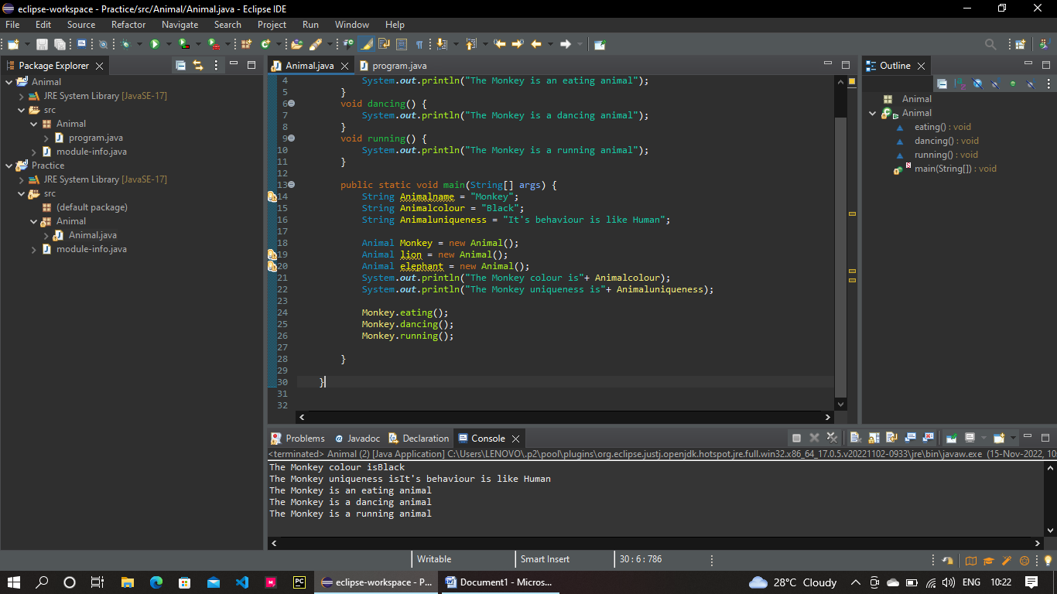

**2.Write a program – using for condition to print the hello world program for 10 times?**

**PROGRAM:**

package Animal;

public class program {

public static void main(String[] args) {

for(int i=0;i<10;i++)

{

System.***out***.println("Hello world");

}

**}**

**}**

**OUTPUT:**

